Dr. Margaret Mayston, AM FCSP PhD

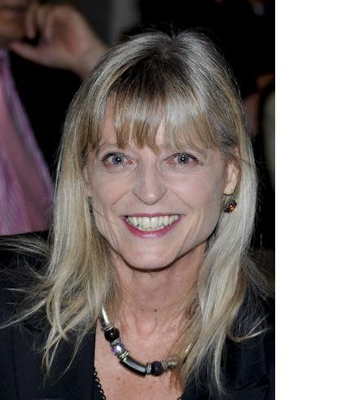

Dr. Margaret Mayston, AM FCSP PhD, Trained in Melbourne, Australia and then worked there as a physiotherapist at the Royal Children’s Hospital. Completed an MSc in Human & Applied Physiology (Kings College London) followed by a PhD and then 3-year Wellcome Trust funded postdoctoral fellowship in neurophysiology at University College London (UCL).
In 2000 she designed an MSc programme in Advanced physiotherapy for Neurophysiotherapists, which incorporated both the adult and paediatric Bobath courses, at the physiology department at UCL where she held a senior lectureship, and was the programme coordinator until 2007.
Margaret is currently a Senior Teaching Fellow in the Division of Biosciences at UCL and Senior Lecturer at the Institute of Child Health (UCL). The ICH post involves working with the team at The Children’s Trust (Tadworth, Surrey) on outcome measure research. She is a senior Bobath tutor, was director of the Bobath Centre in London for several years and now maintains a clinical consultancy role there. She has been a member of the Bobath Centre staff since 1979, teaching since 1981 and worked with Dr & Mrs. Bobath. She travels extensively to teach, is regularly invited to speak at conferences worldwide, and was honoured with a fellowship of the Chartered Society of Physiotherapy (UK) in 2007, the order of Australia (AM) 2009 and the award of Australian Woman of the Year in the UK, 2010 for her work with children with cerebral palsy. She is currently President of ACPIN, the special interest group for neurophysiotherapists in the UK.
She is an Associate Editor of Developmental Medicine and Child Neurology journal.
Recent publications:
Hermon G, Mayston M (submitted): Bone mineral density is reduced in children with severe acquired brain injury.
Appel C, Mayston M, Perry L (2011): Feasibility study of an RCT protocol to examine clinical effectiveness of shoulder strapping in acute stroke patients. Clin Rehabil.;25(9):833-43.
Berthouze L, Mayston, M (2011): Design and validation of surface-marker clusters for the quantification of joint rotations in general movements in early infancy. J Biomechanics, 44(6):1212-5
Mayston MJ (2010): Transition to secondary school: Navigating school-based needs and technological supports for secondary school. In Physiotherapy and Occupational Therapy for People with cerebral Palsy. Ed Dodd KJ, Imms C, Taylor NF. Mac Keith Press. London
Mayston MJ (2008): Bobath@50: midlife crisis- what of the future? Physiotherapy Research International 13 (3): 131-136. Editorial.
Mayston MJ (2007): Motor control in paediatrics. In ‘Physiotherapy for Children’ edited by Theresa Pountney. Elsevier.

