Carolyn Simmons Carlsson

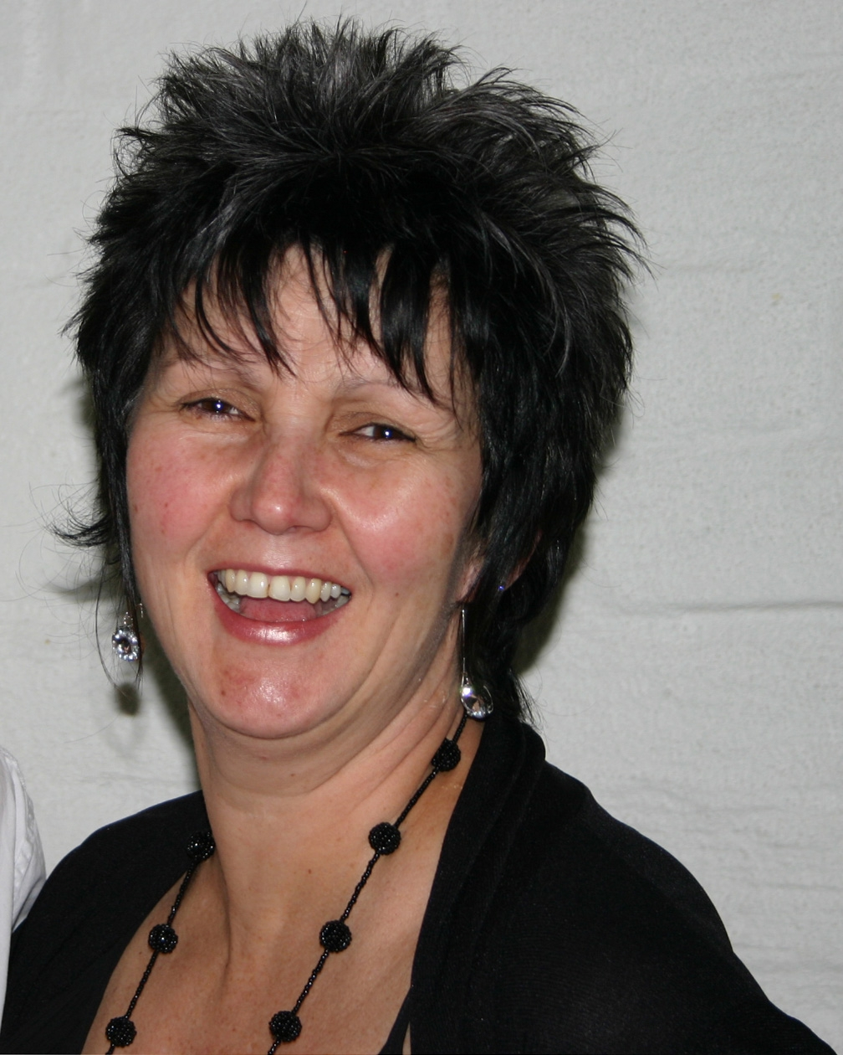

Carolyn Simmons Carlsson graduated as an occupational therapist in 1981. She gained a Postgraduate Diploma of Health Science in 2003; her Master of Health Science in 2006; and was awarded the NZ Association of Occupational Therapists Frances Rutherford Lecture Award in 2008. Her clinical specialty lies is paediatrics, in particular children with neurological conditions; she has worked in a range of children’s services both in New Zealand and the UK. Carolyn gained her Bobath Tutor’s certificate in1995 from the Bobath Centre, London. She teaches on both New Zealand and Australian courses as well as being invited internationally to teach. When not teaching, Carolyn works for the Auckland District Health Board in a leadership role; her private practice in supervision and consultation; and is involved in volunteer therapy work in the Pacific Islands. Her interests lie in inclusive participation outcomes for children and families in their environments and the contextual practice ethos of therapist groups.

