Understanding Normal Movement for Paediatric Therapists

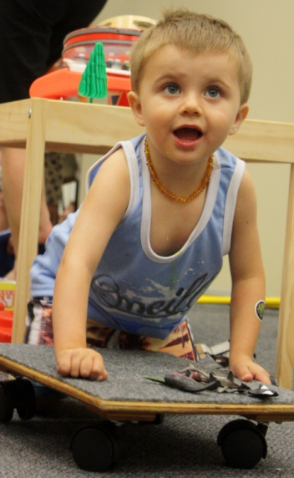
Course description
This two-day course is designed to introduce participants to the concept of movement analysis in the assessment and treatment of children with neurodevelopmental disorders.
Participants will be able to describe key components relating to the analysis of postures and movement sequences and learn how to facilitate movement with the opportunity to practice handling skills.
It is a practical course with the focus on therapists developing their skills of observation of posture and movement, with the practice of facilitation of normal movement.
Date: 11th & 12th May, 2019
Venue: RIDBC Renwick Centre
361-365 North Rocks Road, North Rocks 2151

Course Fee: $660 incl GST
Register through the RIDBC Renwick Centre: https://shortcourses.ridbc.org.au/events/understanding-normal-movement-for-paediatric-therapists/

Enquiries: Trudy Smith (mailcpe@ridbc.org.au)

