Infant Handling: Assessment and Treatment for Infants
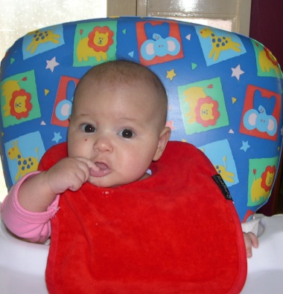
Monday 10th February 2020 – Saturday 15th February 2020

COURSE DESCRIPTION

This is a comprehensive 6-day course focusing on assessment and treatment for infants under 12 months of age.
This course will focus on:
- Infant regulation and bonding,
- Feeding and communication, and
- Maximising developmental progress

There is a clinical component to the course with hands-on facilitation practicals. Please bring a soft doll to use during the facilitation practicals.

The course is open to all paediatric therapists (OT, PT & SP) with at least 2-years’ experience, particularly in early intervention. It is an advanced level course and requires therapists to have completed the Bobath Foundation Course. Alternatively, therapists must complete the following courses as a pre-requisite;
- Typical Child Development, ABNDTA online module
- Understanding Normal Movement, 2-day workshop in Perth 8-9th August 2019 register: https://www.trybooking.com/BAOPN
Venue: Perth, Western Australia (venue tbc)
Fees: The Infant Handling course costs $2200 excl GST, plus booking fees. Registration and further information is available via the following link
https://www.trybooking.com/BDMUU

