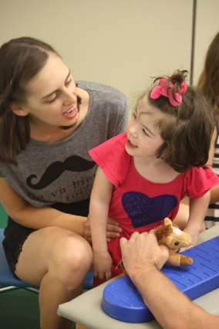
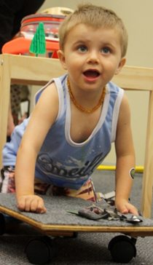
Post Graduate Courses for Paediatric Therapists 2019

ABNDTA are offering the following Professional Development Training and Courses in 2019.

Courses can be completed as single modules, or combined as part of the Foundation Bobath Course.

- Typical Child Development: Understanding typical and atypical sensori-motor development in babies and young children (20 Hrs online, 4th March – 12th April 2019)
Current theories on all aspects of child development are taught using a variety of learning tools including online lectures, videos and practical sessions with babies. Examples of atypical development in children are identified and related to clinical practice. This is a pre-requisite for the Foundation Bobath Course, and the Infant Handling course.
TCD = $800 + GST ($200 rebate if you sign up for the Foundation certification course)

Register here: https://www.trybooking.com/ZRAS

- Understanding normal movement (2-day workshop Geelong 24th – 25th May 2019, Perth 8th – 9th August 2019)
This practical component of the course assists therapist to develop their skills of observing typical movement and the variations of this. Learning how to actively assist a person to learn to move through handling is a key component of this module, as well as its translation into clinical practice in developmental disabilities. This is a pre-requisite for the Foundation Bobath Course, and the Infant Handling course.
Normal Movement workshop = $600 + GST

- Classification (Online module, approx. 30 hours, 1st July – 9th August 2019)
This is an online self-directed learning module which examines the different clinical presentations of Cerebral Palsy, such as Spastic Hypertonia and Dyskinesia. The course delivers theory and evidence-based knowledge around the clinical presentation and treatment principles for the different types of Cerebral Palsy, as well as outcome measure. It also has a number of video examples to support your ability to identify and classify different movement disorders. This is a core component of the Foundation Bobath Course.
Classification = $500 + GST

Register here: https://www.trybooking.com/ZRBC

- Clinical practice (70 Hrs direct face-to-face learning) including Occupational Therapy Theory and Practice & Speech Pathology Theory and Practice

2 x 2-week clinical blocks. Throughout the clinics, participants will have the opportunity to develop their clinical skills under direct supervision of highly skilled and experienced therapists who all currently work in clinical practice using Bobath principles. Children and their families participate in the clinical component, for either demonstration sessions or for the regular sessions throughout the weeks. All ages and stages of children are involved as well as the variety of setting and models of service delivery.

No other post graduate course offers this level of direct clinical supervision with therapists across all disciplines so that a skilled, holistic approach to providing therapy interventions is delivered to babies, children and their families.
Part 1; 2nd September – 13th September
Part 2; 18th November – 29th November
Clinical Blocks = $2500 + GST each

Certification
This course meets the requirements for internationally recognised certification as a Bobath/ NDT therapist

